# MACHINE LEARNING – WORKSHEET 7 with Answers

**All the questions in this exercise have one or more than one correct answers. Choose all the correct options to answer your questions.**

1. Which of the following statements are true regarding SVMs?
   1. SVMs use hyperplanes as decision boundary for classification.
   2. SVMs uses kernel functions to avoid computational load of converting the whole dataset in to higher dimensional space where the data is linearly separable.
   3. SVMs can separate classes only when the data is linearly separable.
   4. SVMs use hard margin classifier.

Answer: ( C )

1. Consider the radial basis kernel function given below and answer the following question: k(x, x0) = exp(−γ||x − x0 ||2)

In the above figure we have two curves for two radial basis function with different values of gammas. Which of these curves has higher values of gamma?

* 1. Red B) Blue

C) Both are equal D) cannot be determined from the curve

Answer: (C )

1. Which of these statements are true regarding the RBF kernel of SVM?
   1. The RBF is used to find the linear classifier for the data in to infinite dimensional space.
   2. Higher the value of gamma of RBF the more flexible the classifier curve becomes in the original dimensions.
   3. A very high value of gamma may lead to overfitting.
   4. None of the above

Answer: ( A )

1. Consider the following graph and answer the question given below:



Consider the above figure where triangles represent class A data points and rectangles represent Class B. Which of the following classifier can be used here?

* 1. A Hard Margin Linear Classifier B) A Soft Margin Linear classifier

C) Both of them can be used D) None of the above

Answer: ( C)

1. Consider the following image and answer the question:

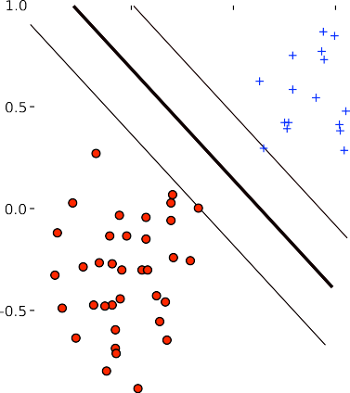

margin

What will happen if we decrease the value of C, the soft margin constant?

* 1. The margin width will decrease B) The margin width will Increase

C) There will be no effect on the margin D) The classifier will become non linear

Answer: (A )

1. Consider the following image and answer the question:

Figure A: Figure B:

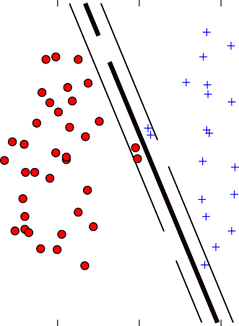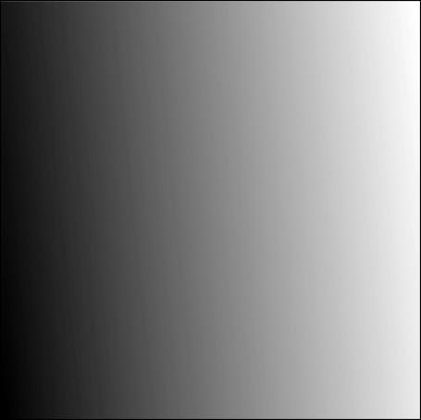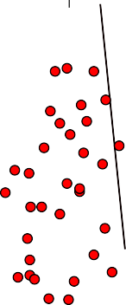

In the above figure red circles represent class A data points and plus sign represents Class B. Both of the figures are on the same data. Among the above given figure-A and Figure-B, which of these figure have higher value of C hyperparameter?

* 1. Figure A B) Figure B

C) Both have same value D) Cannot be determined

Answer: (A )

1. In the following figures red circles represent Class A data points and plus represent Class B data points. We are using a linear kernel with Degrees D1, D2 and D3 as shown in the figures A, B and C respectively.

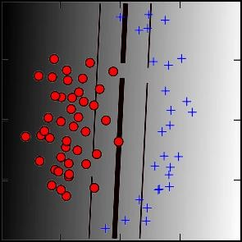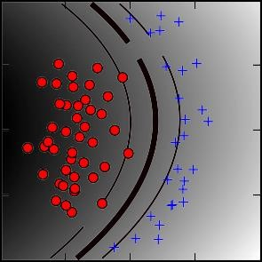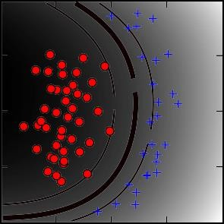Fig A: D1 Degree polynomial Fig B: D2 degree Fig C: D3 degree

Now which of the following is true regarding the degrees?

A) D1>D2>D3 B) D3>D1>D2

C) D3>D2>D1 D) D3=D2=D1

Answer: ( B )

1. In the following figures red circles represent Class A data points and plus represent Class B data points. In the below figures we are using RBF kernel with varying degrees Gamma:

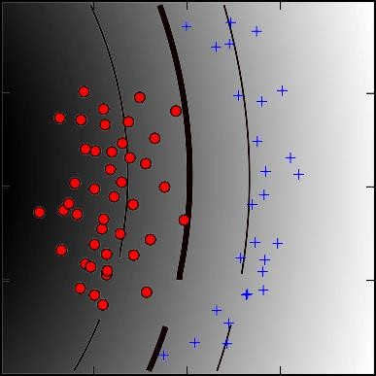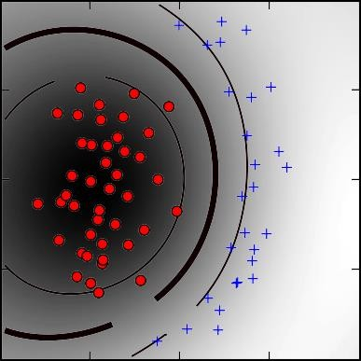Gamma 1 Gamma2

Now choose the correct options:

* 1. Gamma2 = Gamma1 B) Gamma1 > Gamma2

C) Gamma2 > Gamma 1 D) None of the above

Answer: ( B )

1. Let us assume you are using RBF kernel in SVM with a very high Gamma value. What does this signify?
   1. The model would consider even far away points from hyperplane for modelling
   2. The model would consider only the points close to the hyperplane for modelling
   3. The model would not be affected by distance of points from hyperplane for modelling
   4. None of the above

Answer: ( C )

1. What would happen when you use very small C (C~0)?
   1. A large number of misclassification would happen B) Data will be correctly classified

C) Can’t say D) None of these

Answer: (A )